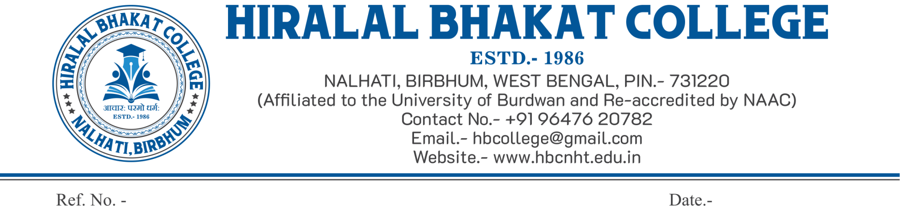

**NOTICE**

It is hereby notified to all the students of B.Com. Hons. Sem-III and Sem-V that your internal examination will be held in offline mode. Bring your almanac and required materials as required for the relevant exam.

Please find the following date and time of your examinations.

|  |  |  |  |  |
| --- | --- | --- | --- | --- |
| **Semester** | **Course Code** | **Name of the Course** | **Date of Examination** | **Time of Examination** |
| **III** | CC-5 | Computer Applications in Business | 16.11.2022 | 11 A.M. to 11.30 A.M. |
| CC-6 | Cost Accounting-II | 11.30 A.M. to 12 Noon |
| CC-7 | Financial Accounting-II | 12 Noon to 12.30 P.M. |
| SEC-1 | E-Commerce | 17.11.2022 | 11 A.M. to 11.30 A.M. |
| GE-3 | Principles of Economics | 11.30 A.M. to 12 Noon |
| **V** | CC-11 | Taxation-I | 20.11.2022 | 11 A.M. to 11.30 A.M. |
| CC-12 | Auditing | 11.30 A.M. to 12 Noon |
| DSE-1 | Management Accounting | 12 Noon to 12.30 P.M. |
| DSE-2 | Indian Financial System | 12.30 P.M. to 1 P.M. |

**Date: 08.11.2022**

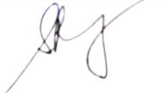

**HOD**

**Department of Commerce**

